**VECTR v5.4 Feature Breakdown**

Table of Contents

Custom Escalation Path Start Icon 2

Database Upgrades on Application Start 3

Disable Tools 4

Display Selected Template on Red Team Details 5

Drag/Drop Handle UI Tweak 6

Edit Assessment Description from Campaign Dashboard 7

Escalation Path Tweaks 8

Filesize Limit Increase for Evidence Files 9

Fix Database Creation Bug 10

Heatmap Counts and Filter Visualization 11

Heatmap Sub-matrix Filters 12

Historical Trending Screen Multiple Trendlines 13

MITRE ATT&CK Technique Autocomplete 15

Next Test Case Button 17

Search Filters for Target Assets and Heatmap Filters 18

Show Import Date and Time for Campaigns 20

Tooltips Improved 21

# Custom Escalation Path Start Icon

What is it?

Allows users to set the icon for the start of their escalation paths in a campaign view.

How does it work?

Click configure on an Assessment housing the campaign:

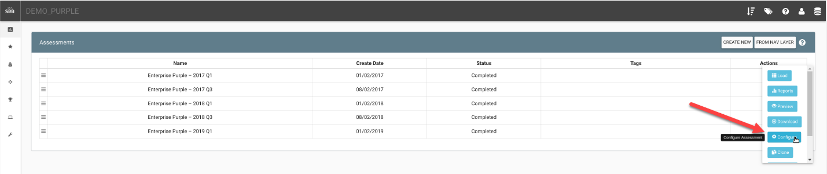

Click the Cog next to the Campaign you want to edit, then the Edit button at the top of the Campaign:  
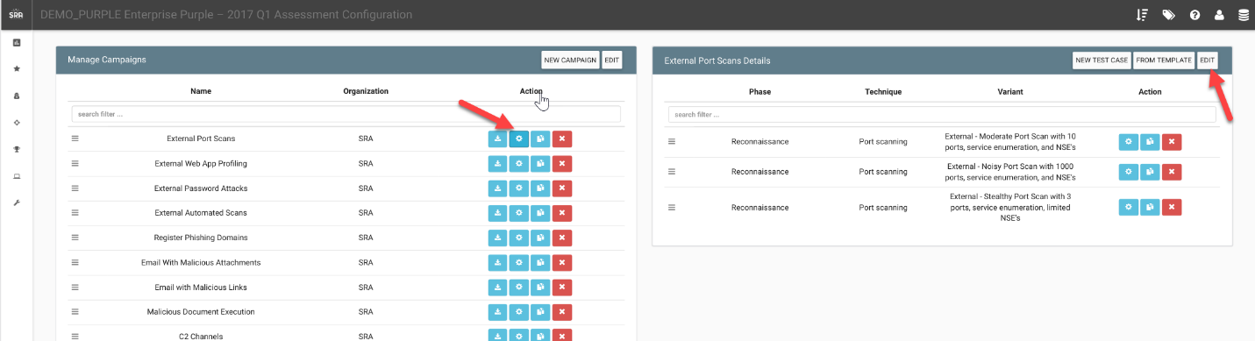

Click the Pick Icon button:

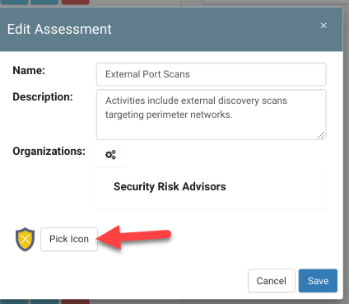

How can this feature help me?

Allows for customization of escalation path for screenshots.

# Database Upgrades on Application Start

What is it?

This feature allows VECTR to automatically update its databases prior to web application startup.

How does it work?

VECTR checks the state of any existing application databases on startup and updates them if necessary. Logs are stored in a separate database for auditing and debugging. This feature may contribute to slightly longer application startup times when databases are being updated.

How can this feature help me?

Users will no longer need to click through upgrade screens after the application is updated.

# Disable Tools

What is it?

Allows tools to not show up in dropdowns, if disabled. Will still show up in reporting.

How does it work?

Example here shows a tool that is still enabled, FTP:

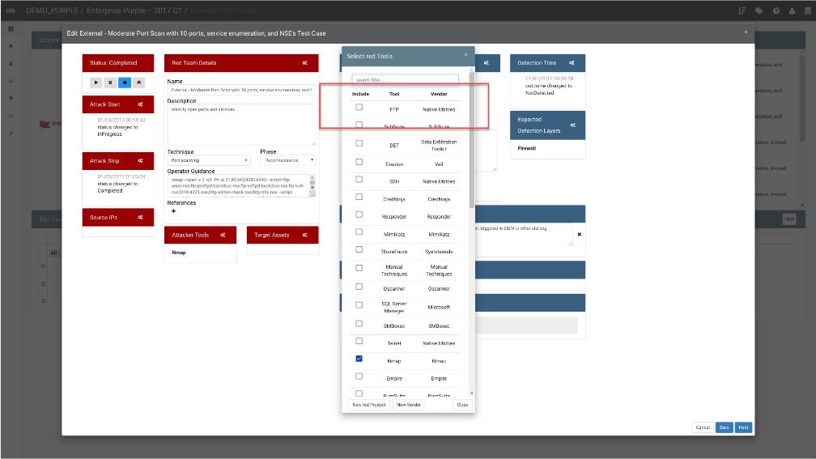

From the Vendors & Tools on the left Nav panel, you can disable tools:

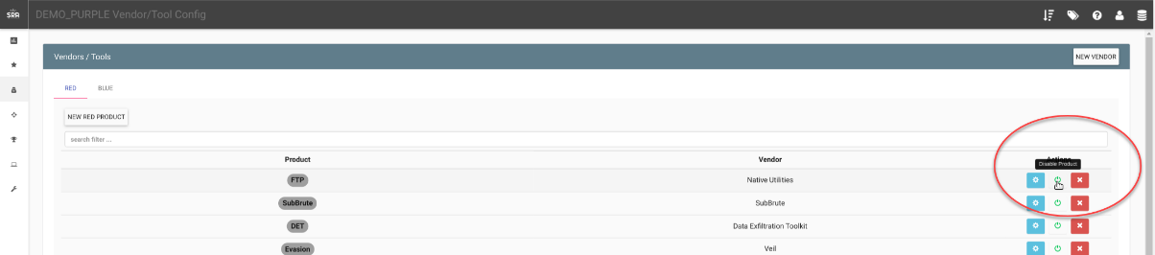

This will prevent the Tool FTP from showing up in the selection screen:  
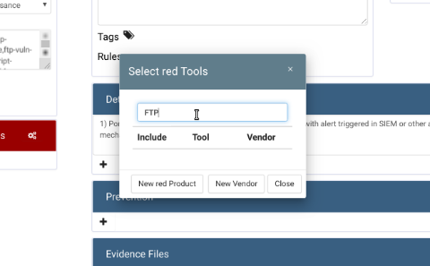

How can this feature help me?

This allows for cleaner dropdowns if your team is using a subset of the tools provided, making it easier to find what you’re using.

# Display Selected Template on Red Team Details

What is it?

Allows for the user to more easily see which admin template is assigned to the test case.

How does it work?

From the Test Case panel, open the properties clicking the Red Team Details cog:

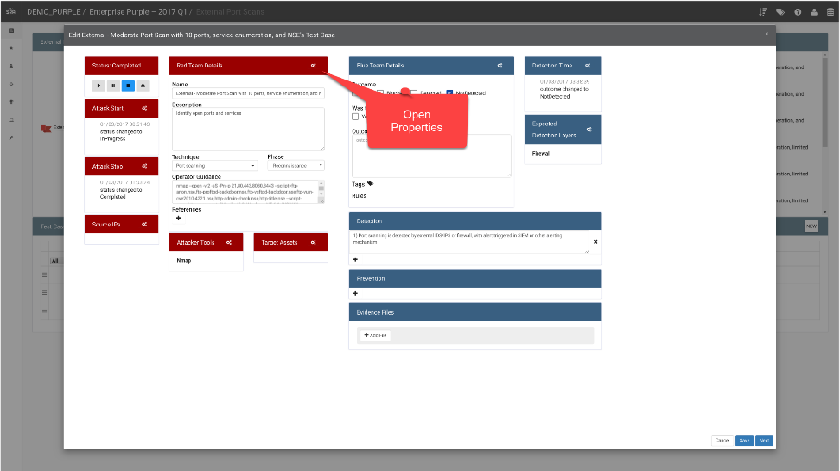

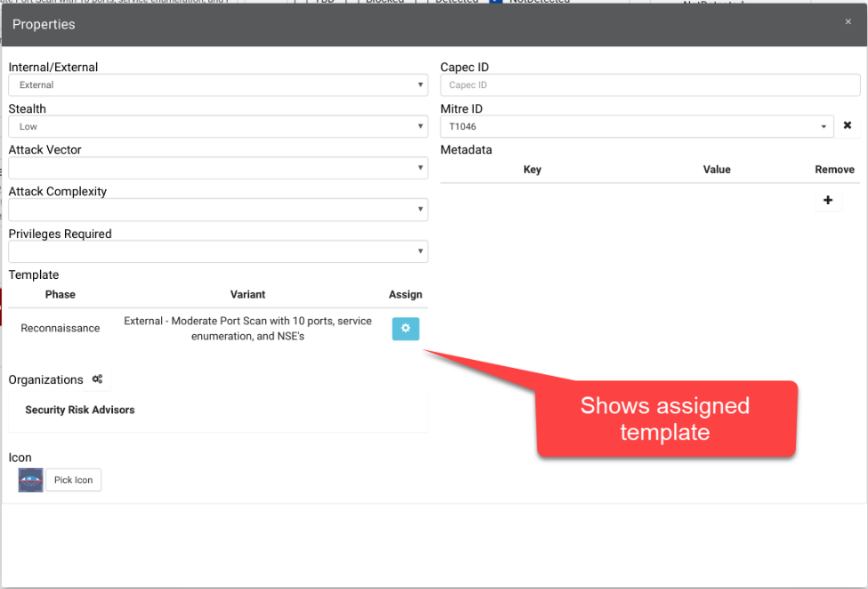

How can this feature help me?

Will allow the user to more easily know which template is assigned to a test case. The template is used in various screens (like Heatmap filters, Detection Rules, etc), and this needs to be more easily extracted from the app.

# Drag/Drop Handle UI Tweak

What is it?

Data that can be ordered in VECTR is now moved by dragging and dropping a drag handle in the UI.

How does it work?

Reorder data row items by using the drag and drop handle on appropriate data.

How can this feature help me?

Previously the data rows themselves where able to be drag and dropped by clicking and dragging the row, but this was confusing users and causing unintended ordering behavior. This new feature should make the drag and drop action easier to use and more deliberate.

# Edit Assessment Description from Campaign Dashboard

What is it?

Allows for editing an Assessment from the Campaign Dashboard

How does it work?

Click the Edit button:  
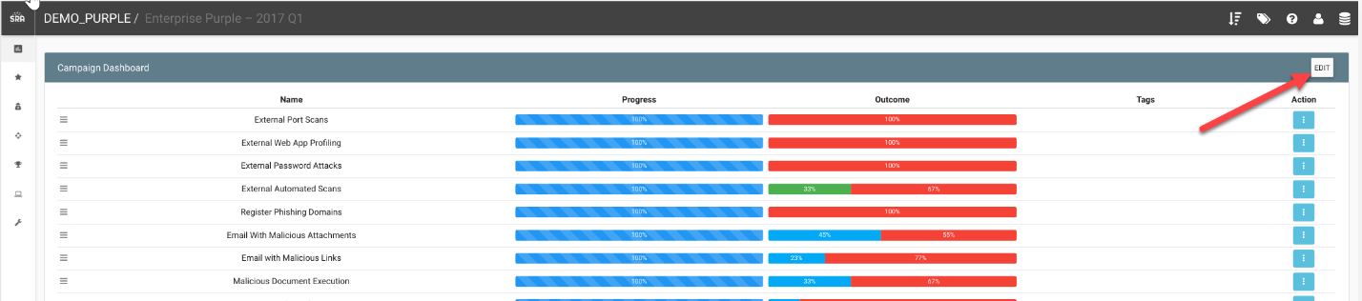

How can this feature help me?

Allows for easier access to editing an Assessment

# Escalation Path Tweaks

What is it?

This feature improves the spacing and visibility of the Escalation Path on the Campaign detailed view.

How does it work?

The Escalation Path has been modified to limit the amount of text overlap shown. Additionally, the Escalation Path viewport height can be modified via a +/- button in the UI and the horizontal length of the diagram is now scrollable in a user’s web browser.

How can this feature help me?

The Escalation Path should be easier to visually navigate and understand how a Campaign’s Test Cases are divided among Kill Chain Phases.

# Filesize Limit Increase for Evidence Files

What is it?

A 190 MB file size limit has been added to VECTR’s evidence files upload feature.

How does it work?

The UI will display a warning if a user tries to upload a file greater than 190MB.

How can this feature help me?

Previously, uploading large files could cause the front-end to become unstable, and there was no visual indicator of what the application was doing. Until the VECTR team adds a configurable file size limit, this makes the interface more manageable.

# Fix Database Creation Bug

What is it?

This fixes a bug where empty databases could be created by a combination of users accessing previously deleted databases.

How does it work?

This corrects the issue of empty databases being created.

How can this feature help me?

If you have encountered this issue it will now be fixed. There may be some instances where previously created empty databases will need to be manually deleted.

# Heatmap Counts and Filter Visualization

What is it?

Shows currently applied data filters to your Heatmap, along with various statistics on the visible data.

How does it work?

Click either MITRE FILTERS and/or VECTR FILTERS, select filters.

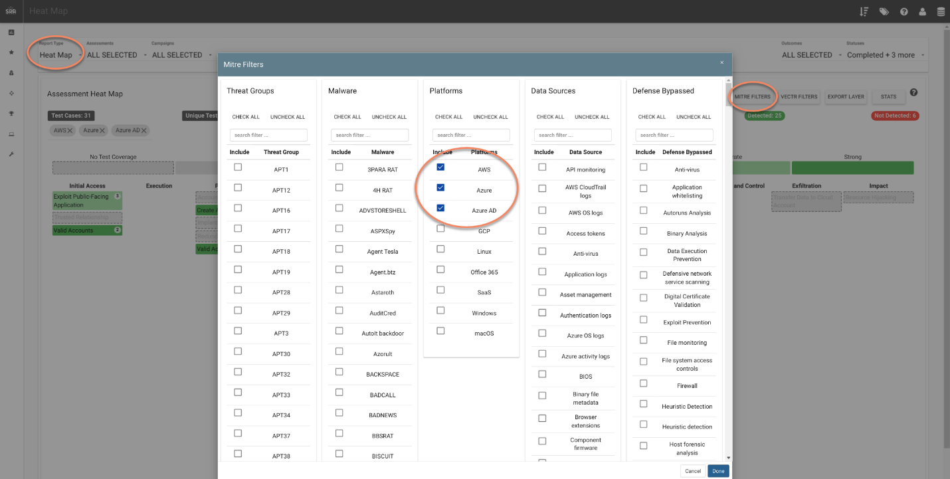

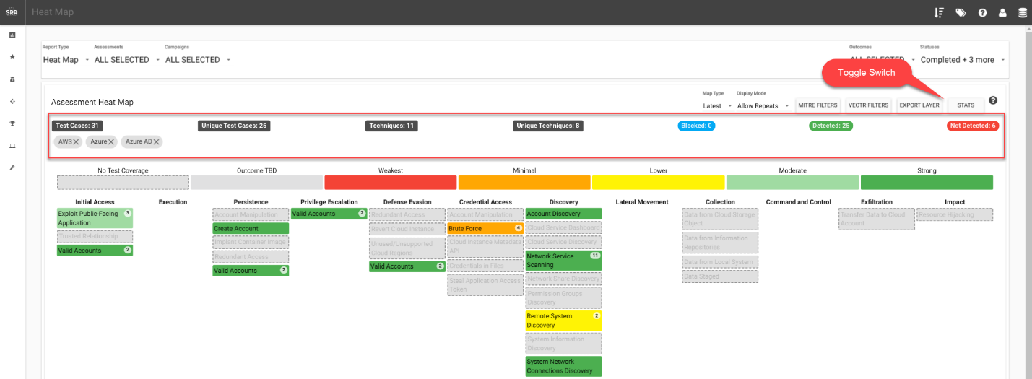

How can this feature help me?

Allows for visuals to show which filters are applied, along with easier to read counts of test cases and techniques.

# Heatmap Sub-matrix Filters

What is it?

Added different Enterprise filters to the Heatmap that are defined by MITRE Matrices. See <https://attack.mitre.org/matrices/enterprise/>

How does it work?

From the Heatmap Reporting screen, click the MITRE FILTERS button:

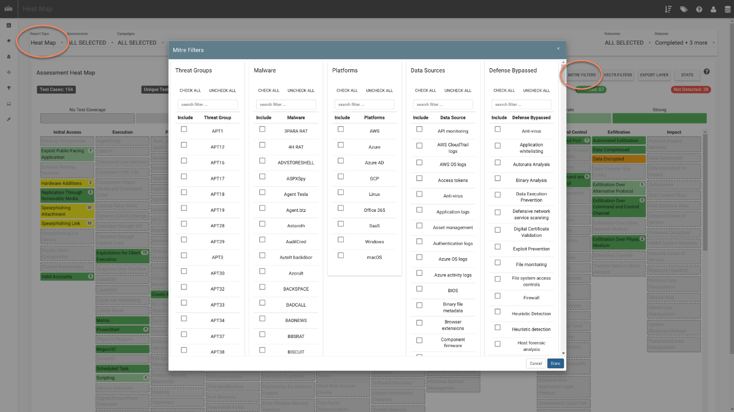

How can this feature help me?

This will allow you to see theoretical coverage of techniques run by test cases from various assessments and campaigns.

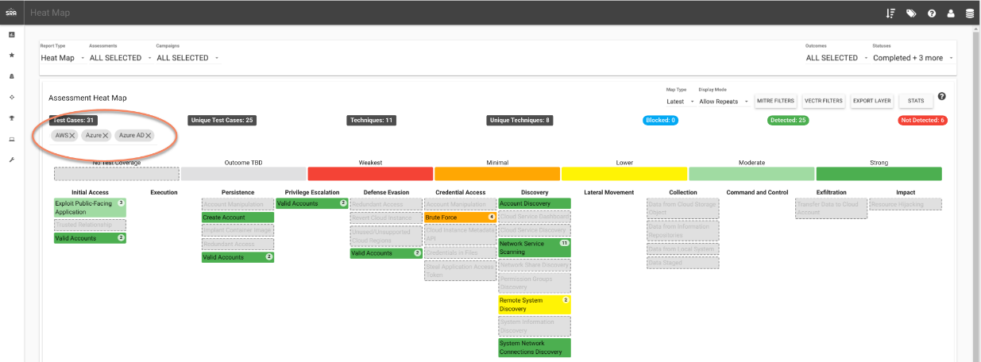

# Historical Trending Screen Multiple Trendlines

What is it?

Allows users to see how data is trending over time based on a Phases/Tactics, Attacker Tools, Tags, or Defensive Layers

How does it work?

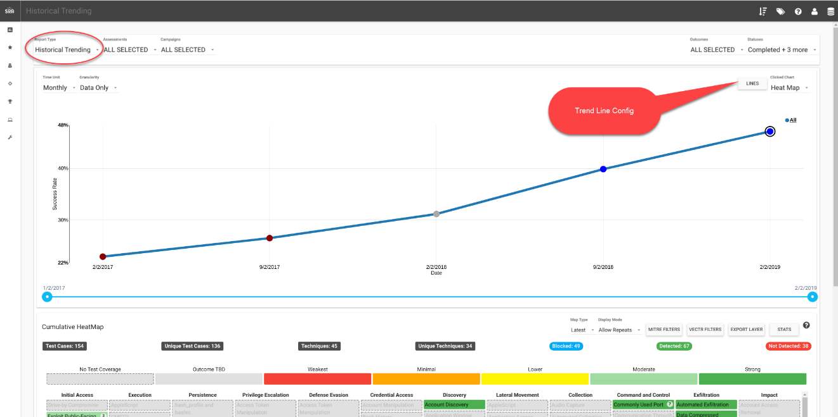

Click on data that you want to see historically trended:

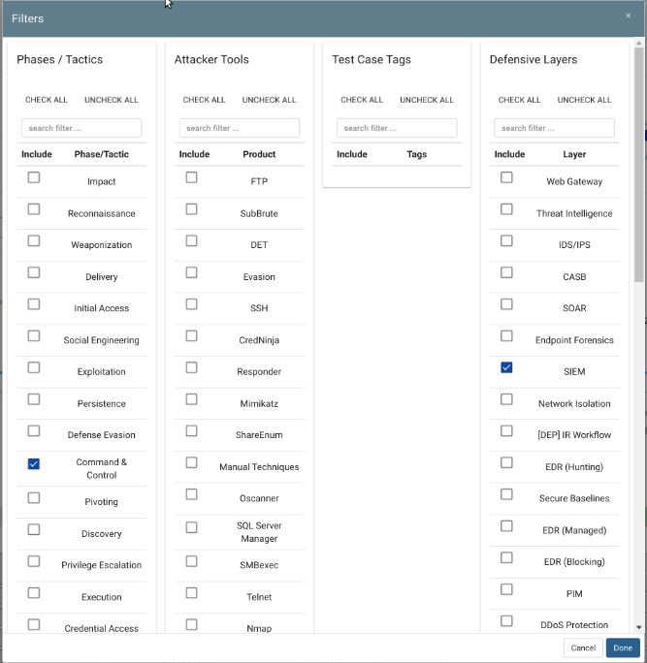

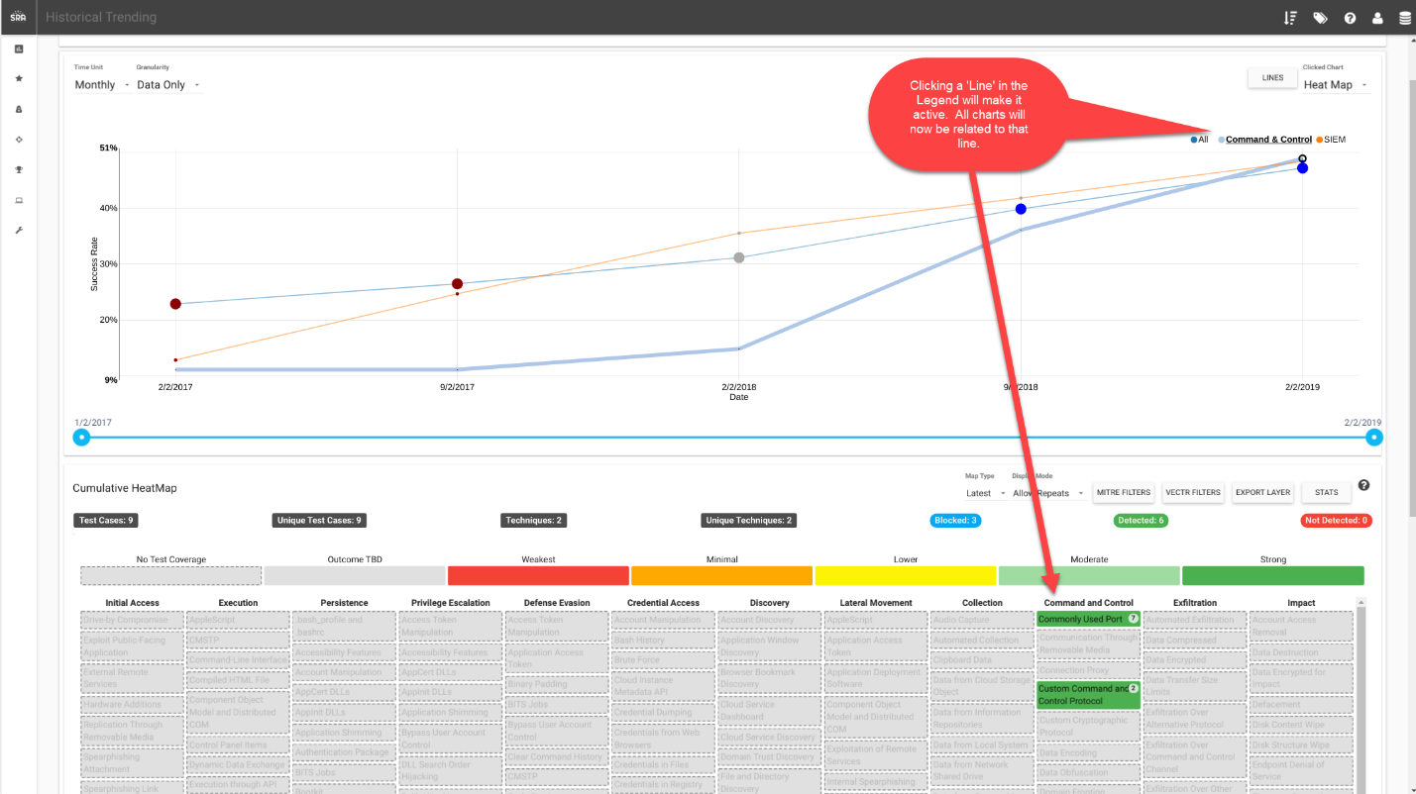

How can this feature help me?

This allows users to see how they are trending to different aspects of their program, whether it be tagged data, a specific phase/tactic, or a defensive tool.

# MITRE ATT&CK Technique Autocomplete

What is it?

This feature adds autocomplete capability to the Technique dropdown on the Test Case screen.

How does it work?

When entering a Technique on the Test Case screen the UI will now show a list of matching MITRE ATT&CK Techniques and ID’s. Entering data here will automatically populate the Red Team Details so that the Test Case shows up appropriately in the Heatmap view.

Additionally, when manually entering a Mitre ID on the Red Team Details screen (by clicking the cog in the Red Team Details header on the Test Case Screen) the Mitre ID will show an autocomplete list.

How can this feature help me?

This will make it easier for Red Team operators to create new Test Cases and assign them to the appropriate MITRE ATT&CK Technique.

# Next Test Case Button

What is it?

A Next button has been added to the Test Case panel to cycle through Test Cases in a campaign.

How does it work?

Clicking the “Next” button on the Test Case panel will update the view with the next available Test Case for a Campaign.

How can this feature help me?

This feature makes it easier for users to navigate Test Cases during a comprehensive Purple Team exercise.

# Search Filters for Target Assets and Heatmap Filters

What is it?

Search filter fields have been added for Heatmap filters and the Target Assets screen.

How does it work?

Type a word or characters to refine data shown in the following data tables. Then select your desired data. This example shows a listing of searchable Heatmap filters.  
  
The Target Assets screen is also searchable to make it easier to manage larger data sets.

How can this feature help me?

This feature makes it quicker to find and select desired data in the system.

# Show Import Date and Time for Campaigns

What is it?

The Campaign Templates screen will now show an Import Date column.

How does it work?

Import Date is populated for any campaigns that have been imported from an external source like the MITRE CTI enterprise-attack json file.

How can this feature help me?

It’s helpful for operators to know when a campaign was last imported to determine if there have been updates or if a campaign may be out of date.

# Tooltips Improved

What is it?

Tooltips have been standardized and added to more fields in VECTR.

How does it work?

Hover over a field to see a tooltip with a name or description of the control. VECTR previously had tooltips, but they were uncommon and not attached to all controls that might need explanation.

How can this feature help me?

Additional tooltips were added to improve the usability of the application.